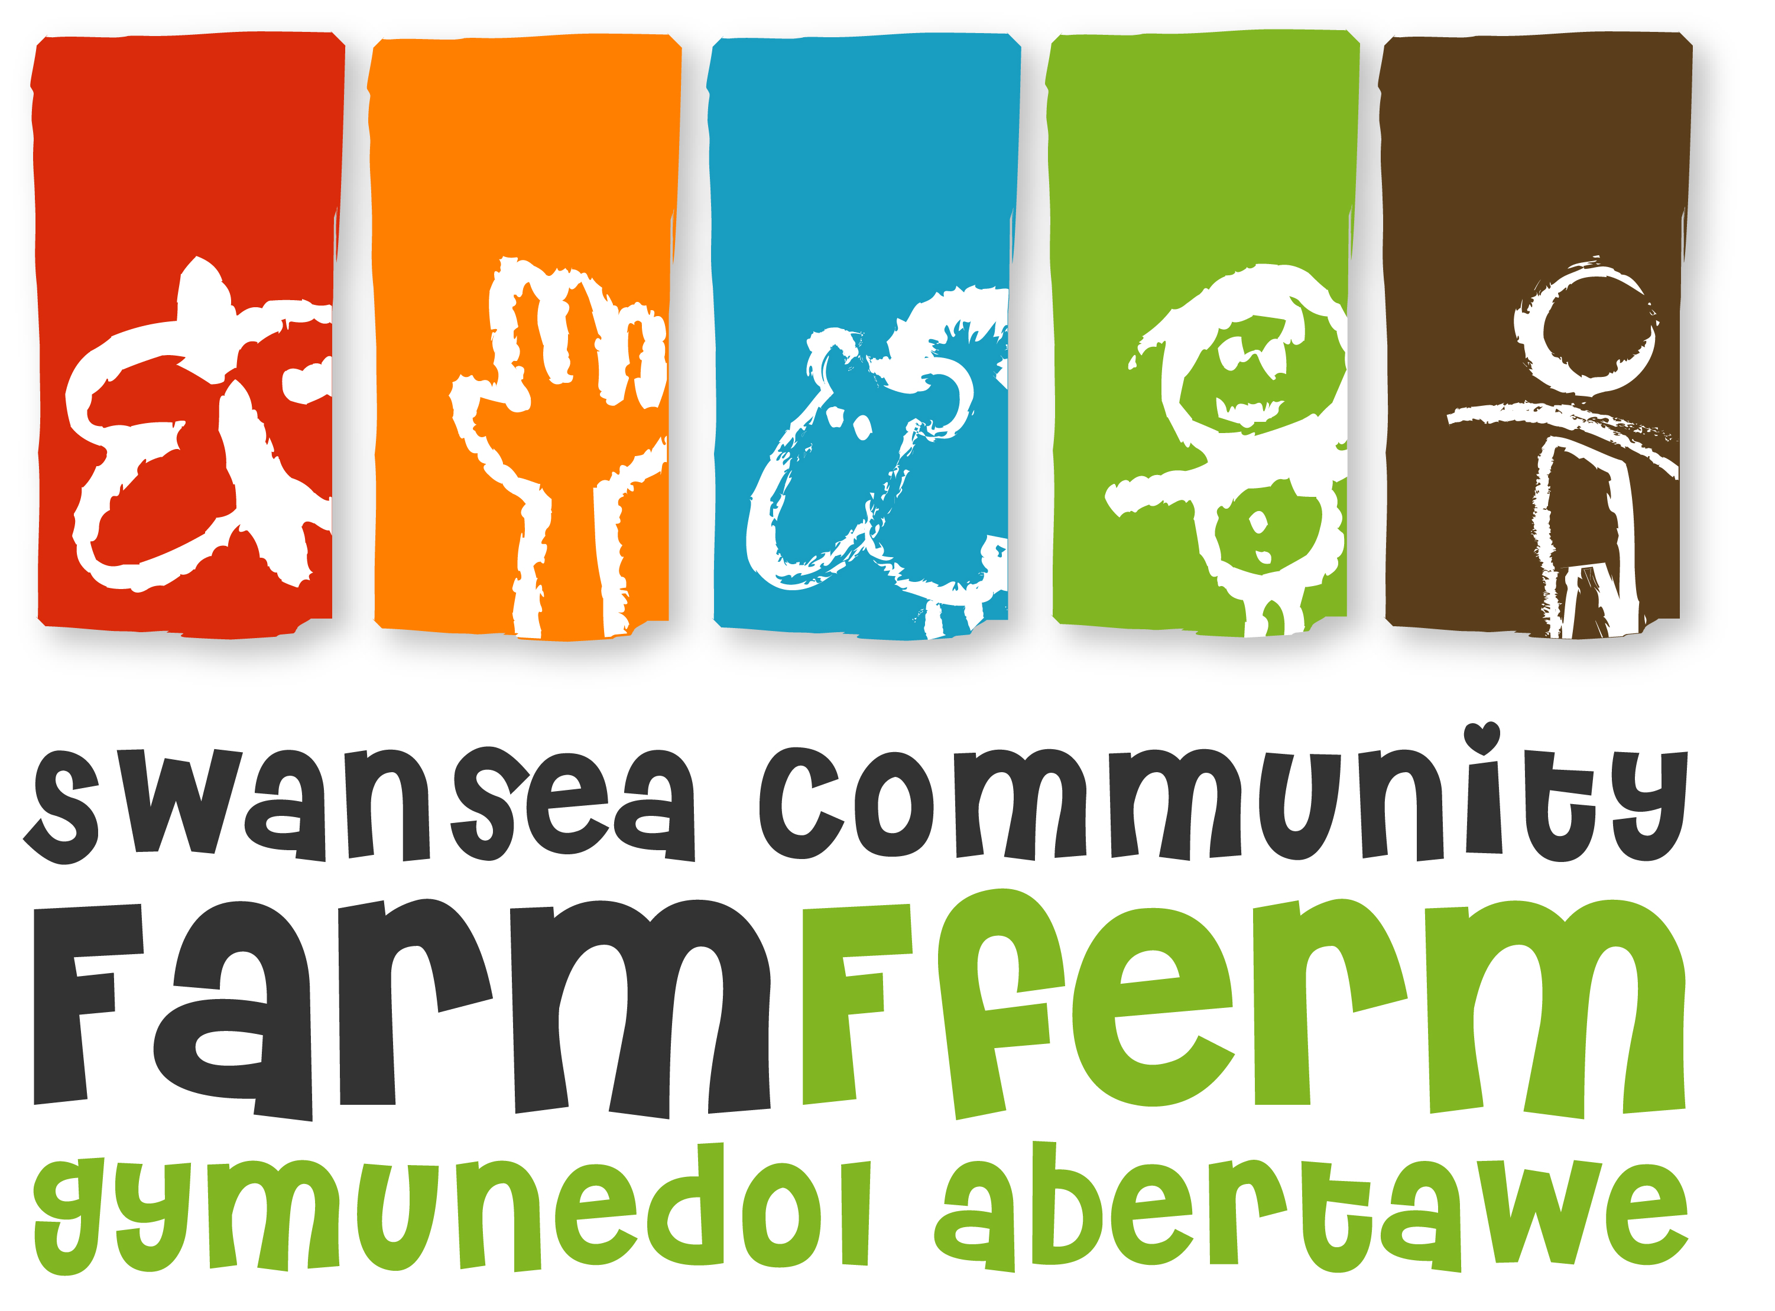
Swansea Community Farm
Job Description

Job Title: Child and Youth Worker (CYW)
Responsible To: Volunteer and Training Manager (VTM) and the Board of Trustees
Responsible For. Assisting with the development and lead delivery of the Growing Stronger Project. Alongside the Farm’s young people, you will develop, manage and run a range of practical activities (incorporating training opportunities, development sessions, consultation and evaluation and play sessions) for young people, aged 2 to 18 years, prioritising those who face disadvantage. These activities aim to improve the health, wellbeing, social skills, self-esteem, confidence levels, aspirations and practical knowledge of young people, enabling them to deal positively with the increased risks and challenges that come from the disadvantages they face, such as growing up in a deprived community or having a disability of some kind.
Pay Scale: SCP 20 £8402 per year (Equivalent to £19,430 pro rata)
Hours: 16 hours a week as part of Growing Stronger. Average of 3-5 hours additional hours per week likely through Playscheme activities during holidays. The post holder will be required to work flexible hours in accordance with the requirements of the organisation and the Flexible Working Hours Policy. This will require working out of school hours, on Saturdays and Sundays, and occasional Bank Holidays and evenings as and when necessary.
Annual Leave: 28 days p.a. plus statutory bank holidays, pro rata
Principal Duties and Responsibilities
- Support the VTM in the delivery and development of a range of practical activities, training opportunities, development sessions and play initiatives etc. for children and young people at the Farm, including the Youth Forum Sessions, After-school Sessions, inclusive Placements, Saturday Farm Club, Sunday Training sessions, Community Activity Days, Play Scheme Opportunities, Open Days/Promotional Events and Residentials.
- To work alongside the young people making sure that activities and opportunities are youth-led, ensuring that young people have a voice within the project, Farm and community.
- To ensure the Farm’s induction processes for new young beneficiaries are correctly delivered, focusing particularly on the Behavioural Policy, Child Protection and Health & Safety requirements.
- To ensure that the children and young people are involved in the evaluation of their opportunities and undertake the monitoring of children/young people’s progress on a regular basis.
- To undertake the role of an advocate and enable self-advocacy of beneficiaries/volunteers.

Programme Delivery and Management
- To be a key contact for all people seeking information relating to the Farm’s Child and Youth project and activities suitable for children and young people.
- To take responsibility for implementation of Health and Safety issues relating to the Child and Youth activities as appropriate including the preparation of activity site checks and risk assessments.
- To seek feedback from children and young people using fun and stimulating consultative techniques.
- To maintain accurate records of work undertaken for use in monitoring and evaluation, to include statistical and qualitative evidence and overseeing C&Y data entry onto the Evide database.
- Assist in the preparation of the venue and materials required to support group work or work with individual children and young people.
- To promote the project and increase participation of target children, young people and adult volunteers assisting in the project.
- To provide opportunities for the individual development of children and young people.
- To manage and support sessional support staff and adult volunteers supporting the project.
- To work outdoors and with animals as and when necessary.
- To oversee the use of the kitchen when used for Child and Youth activities ensuring hygiene standards are adhered to.
- To ensure a high standard of customer care when dealing with the visiting public and delivering activities.
- To adhere to all policies and procedures at Swansea Community Farm, paying particular attention to Child Protection, Protection of Vulnerable People, Healthy and Safety and Equal Opportunities.
- To positively promote the funders of the Farm’s Child and Youth Programme and the Growing Stronger Project.
- To fulfil all the above duties and any other realistic requests from your line supervisor or the board of trustees.

Finance/Administration
- To ensure efficient handling of monies and receipts in accordance with Farm financial procedures.
- To assist the VTM in:
- the future development of the Farm’s projects involving or concerning children and young people;
- the ongoing development, coordination and implementation of the Farm's Safeguarding, Child Behaviour, Vulnerable Adults and Health & Safety policies and ensure that staff, volunteers, consultants and sub-contractors operate within these guidelines.
- the control of budgets;
- the preparation of reports of presentations in line with funding requirements to communicate impact to funders and stakeholders.
- Researching and preparing funding applications for the project and other related activities.

Working Relationships
- To foster and maintain good communication and positive collaboration between staff, the Board of Trustees, volunteers, children and young people.
- To participate in the general operation and management of the Farm, including weekend working on a regular basis and being part of the animal feeding rota on Sundays.
- To participate in working groups, staff training events and meetings for the purpose of the projects development.

NB: Your Line Supervisor and management team have the right to review or vary this Job Description. This post is subject to a 3 month probation period. This job description is as currently applies, but it will be reviewed as required and may be subject to variation. The post holder may be required to undertake other tasks that can reasonably be assigned, which are within their capability and grade.

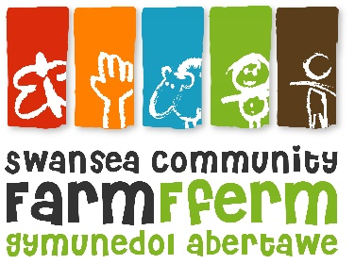Swansea Community Farm
Person Specification

Job Title: Child and Youth Worker

 | Essential | Desirable
Education: | Good general educational attainment or similar demonstrated level of ability.  Suitable qualification although operational experience may be considered in lieu. | Play Leader trained.  Youth Work qualified.
Experience: | Minimum of three years’ work experience with both children and young people in a community setting.  Working with children and young people with challenging behaviour.  Gardening, horticulture and/or animal husbandry experience | Experience of developing programmes for children and young people in a community setting.  Fund raising  Managing staff and resources
Skills and abilities: | Candidates must demonstrate:  - Good communication skills, both written and verbal.  - good organisational skills and time management  - The ability to establish good working relationships with people of all ages.  - A willingness to be available to work flexible hours which will include weekend and evening and holiday work.  - An ability to work independently and as part of a team.  - Competent IT skills (word processing, spreadsheets, database etc.)  - Practical skills: gardening; horticulture; animal husbandry; construction; conservation | Welsh speaker  Hold a driving licence
Values and attitudes: | Candidates should have a commitment to:  - The Farm’s Equal Opportunities Policy and anti-oppressive practices and an appreciation of how the policy affects procedures and practices at the Farm.  - the Rights of the Child  - the aims and objectives of Swansea Community Farm  - an open and non-judgmental attitude  - a willingness to undertake relevant training | A commitment to and interest in environmental issues.
Knowledge | A good understanding of Child Protection issues  Practical knowledge of First Aid and risk assessments | Knowledge of the local area

